**SCD Lab 05**

**Name:** Hafsa Salman

**Roll no.** 22K-5161

**Task no. 01**

Code:

//Hafsa Salman  
//22K-5161  
//Task no. 01: main  
  
import javax.swing.*;  
import java.awt.event.ActionEvent;  
import java.awt.event.ActionListener;  
import java.util.ArrayList;  
  
public class Task_01 extends JFrame  
{  
 private JPanel Task_01;  
 private JButton Add;  
 private JButton Display;  
 private JButton Search01;  
 private JButton Search02;  
 private JButton Remove;  
 private JLabel Label;  
  
 public Task_01()  
 {  
 ArrayList<Books> BooksList = new ArrayList<Books>();  
  
 Books newBook01 = new Books("The Thursday Murder Club", "Richard Osman", "123ABC");  
 BooksList.add(newBook01);  
  
 Books newBook02 = new Books("The Silent Patient", "Alex Michaelides", "456DEF");  
 BooksList.add(newBook02);  
  
 Books newBook03 = new Books("The Da Vinci Code", "Dan Brown", "ABCDEF");  
 BooksList.add(newBook03);  
  
 Add.addActionListener(new ActionListener()  
 {  
 @Override  
 public void actionPerformed(ActionEvent e)  
 {  
 new Add_Task_01(BooksList);  
 }  
 });  
  
 Display.addActionListener(new ActionListener()  
 {  
 @Override  
 public void actionPerformed(ActionEvent e)  
 {  
 new Display_Task_01(BooksList);  
 }  
 });  
  
  
 Search01.addActionListener(new ActionListener()  
 {  
 @Override  
 public void actionPerformed(ActionEvent e)  
 {  
 new SearchByISBN(BooksList);  
 }  
 });  
  
  
 Search02.addActionListener(new ActionListener()  
 {  
 @Override  
 public void actionPerformed(ActionEvent e)  
 {  
 new SearchByTitle(BooksList);  
 }  
 });  
  
  
 Remove.addActionListener(new ActionListener()  
 {  
 @Override  
 public void actionPerformed(ActionEvent e)  
 {  
 new Remove(BooksList);  
 }  
 });  
 }  
  
 public static void main(String[] args)  
 {  
 Task_01 T1 = new Task_01();  
  
 T1.setContentPane(T1.Task_01);  
 T1.setTitle("Book Library Management (22K-5161)");  
 T1.setSize(500, 500);  
 T1.setVisible(true);  
  
 T1.setDefaultCloseOperation(JFrame.*EXIT_ON_CLOSE*);  
 }  
}  
  
class Books  
{  
 String name;  
 String author;  
 String ISBN;  
  
 public Books(String name, String author, String ISBN)  
 {  
 this.name = name;  
 this.author = author;  
 this.ISBN = ISBN;  
 }  
}

//Hafsa Salman  
//22K-5161  
//Task no. 01: Add Book  
  
import javax.swing.*;  
import java.awt.event.ActionEvent;  
import java.awt.event.ActionListener;  
import java.util.ArrayList;  
  
public class Add_Task_01 extends JFrame  
{  
 private JLabel AddLabel;  
 private JLabel Name;  
 private JTextField BookName;  
 private JLabel Author;  
 private JTextField AuthorName;  
 private JLabel Isbn;  
 private JTextField BookISBN;  
 private JButton AddBookBtn;  
 private JPanel AddBooks;  
  
  
 public Add_Task_01(ArrayList<Books> BooksList)  
 {  
 setContentPane(AddBooks);  
 setTitle("Book Library Management (22K-5161)");  
 setSize(500, 500);  
 setVisible(true);  
  
 AddBookBtn.addActionListener(new ActionListener()  
 {  
 @Override  
 public void actionPerformed(ActionEvent e)  
 {  
 String title = BookName.getText();  
 String author = AuthorName.getText();  
 String isbn = BookISBN.getText();  
  
 if (title.isEmpty() || author.isEmpty() || isbn.isEmpty())  
 {  
 JOptionPane.*showMessageDialog*(AddBookBtn, "Please Enter All Fields");  
 }  
  
 else  
 {  
 Books newBooks = new Books(title, author, isbn);  
 BooksList.add(newBooks);  
  
 new Display_Task_01(BooksList);  
 dispose();  
 }  
 }  
 });  
 }  
}

//Hafsa Salman  
//22K-5161  
//Task no. 01: Display Books  
  
import javax.swing.*;  
import javax.swing.table.DefaultTableModel;  
import java.awt.*;  
import java.util.ArrayList;  
  
public class Display_Task_01 extends JFrame  
{  
 public Display_Task_01(ArrayList<Books> BooksList)  
 {  
 setTitle("Book Library Management (22K-5161)");  
 setSize(500, 500);  
 setVisible(true);  
  
 String[] columnNames = {"Name", "Author", "ISBN"};  
  
 Object[][] data = new Object[BooksList.size()][columnNames.length];  
  
 for (int i = 0; i < BooksList.size(); i++)  
 {  
 Books book = BooksList.get(i);  
 data[i][0] = book.name;  
 data[i][1] = book.author;  
 data[i][2] = book.ISBN;  
 }  
  
 DefaultTableModel model = new DefaultTableModel(data, columnNames);  
  
 JTable table = new JTable(model);  
  
 JScrollPane scrollPane = new JScrollPane(table);  
  
 add(scrollPane, BorderLayout.*CENTER*);  
 }  
}

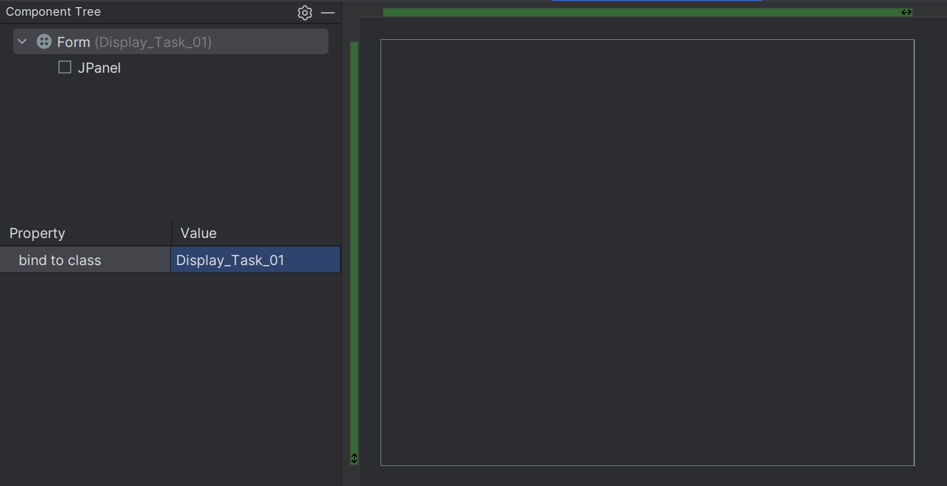

//Hafsa Salman  
//22K-5161  
//Task no. 01: Search By ISBN  
  
import javax.swing.*;  
import java.awt.event.ActionEvent;  
import java.awt.event.ActionListener;  
import java.util.ArrayList;  
  
public class SearchByISBN extends JFrame  
{  
 private JTextField textField1;  
 private JPanel SearchISBN;  
 private JButton searchButton;  
 private JLabel Search;  
  
 public SearchByISBN(ArrayList<Books> BooksList)  
 {  
 setContentPane(SearchISBN);  
 setTitle("Book Library Management (22K-5161)");  
 setSize(500, 500);  
 setVisible(true);  
  
 searchButton.addActionListener(new ActionListener()  
 {  
 @Override  
 public void actionPerformed(ActionEvent e)  
 {  
 String ISBN = textField1.getText();  
 boolean found = false;  
  
 for (int i = 0; i < BooksList.size(); i++)  
 {  
 Books book = BooksList.get(i);  
  
 if (book.ISBN.equals(ISBN))  
 {  
 JOptionPane.*showMessageDialog*(searchButton, "Book Found!\n" + "Title: " + book.name + "\n" + "Author: " + book.author + "\n" + "ISBN:" + book.ISBN);  
  
 found = true;  
  
 break;  
 }  
 }  
  
 if (!found)  
 {  
 JOptionPane.*showMessageDialog*(searchButton, "No book found!");  
 }  
 }  
 });  
 }  
}

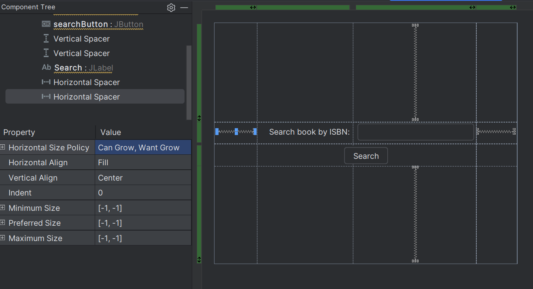

//Hafsa Salman  
//22K-5161  
//Task no. 01: Search By Book Title  
  
import javax.swing.*;  
import java.awt.event.ActionEvent;  
import java.awt.event.ActionListener;  
import java.util.ArrayList;  
  
public class SearchByTitle extends JFrame  
{  
 private JTextField textField1;  
 private JButton Search;  
 private JLabel searchbook;  
 private JPanel SearchTitle;  
  
 public SearchByTitle(ArrayList<Books> BooksList)  
 {  
 setContentPane(SearchTitle);  
 setTitle("Book Library Management (22K-5161)");  
 setSize(500, 500);  
 setVisible(true);  
  
 Search.addActionListener(new ActionListener()  
 {  
 @Override  
 public void actionPerformed(ActionEvent e)  
 {  
 String title = textField1.getText();  
 boolean found = false;  
  
 for (int i = 0; i < BooksList.size(); i++)  
 {  
 Books book = BooksList.get(i);  
  
 if (book.name.equals(title))  
 {  
 JOptionPane.*showMessageDialog*(Search, "Book Found!\n" + "Title: " + book.name + "\n" + "Author: " + book.author + "\n" + "ISBN: " + book.ISBN);  
  
 found = true;  
  
 break;  
 }  
 }  
  
 if (!found)  
 {  
 JOptionPane.*showMessageDialog*(Search, "No book found!");  
 }  
 }  
 });  
 }  
}

//Hafsa Salman  
//22K-5161  
//Task no. 01: Remove Book  
  
import javax.swing.*;  
import java.awt.event.ActionEvent;  
import java.awt.event.ActionListener;  
import java.util.ArrayList;  
  
public class Remove extends JFrame  
{  
 private JLabel Label;  
 private JTextField textField1;  
 private JButton removeButton;  
 private JPanel RemoveISBN;  
  
 public Remove(ArrayList<Books> BooksList)  
 {  
 setContentPane(RemoveISBN);  
 setTitle("Book Library Management (22K-5161)");  
 setSize(500, 500);  
 setVisible(true);  
  
 removeButton.addActionListener(new ActionListener()  
 {  
 @Override  
 public void actionPerformed(ActionEvent e)  
 {  
 String ISBN = textField1.getText();  
 boolean found = false;  
  
 for (int i = 0; i < BooksList.size(); i++)  
 {  
 Books book = BooksList.get(i);  
  
 if (book.ISBN.equals(ISBN))  
 {  
 BooksList.remove(i);  
 JOptionPane.*showMessageDialog*(removeButton, "Book removed!");  
  
 found = true;  
  
 break;  
 }  
 }  
  
 if (found)  
 {  
 new Display_Task_01(BooksList);  
 dispose();  
 }  
  
 else  
 {  
 JOptionPane.*showMessageDialog*(removeButton, "No book found!");  
 }  
 }  
 });  
 }  
}

Output:

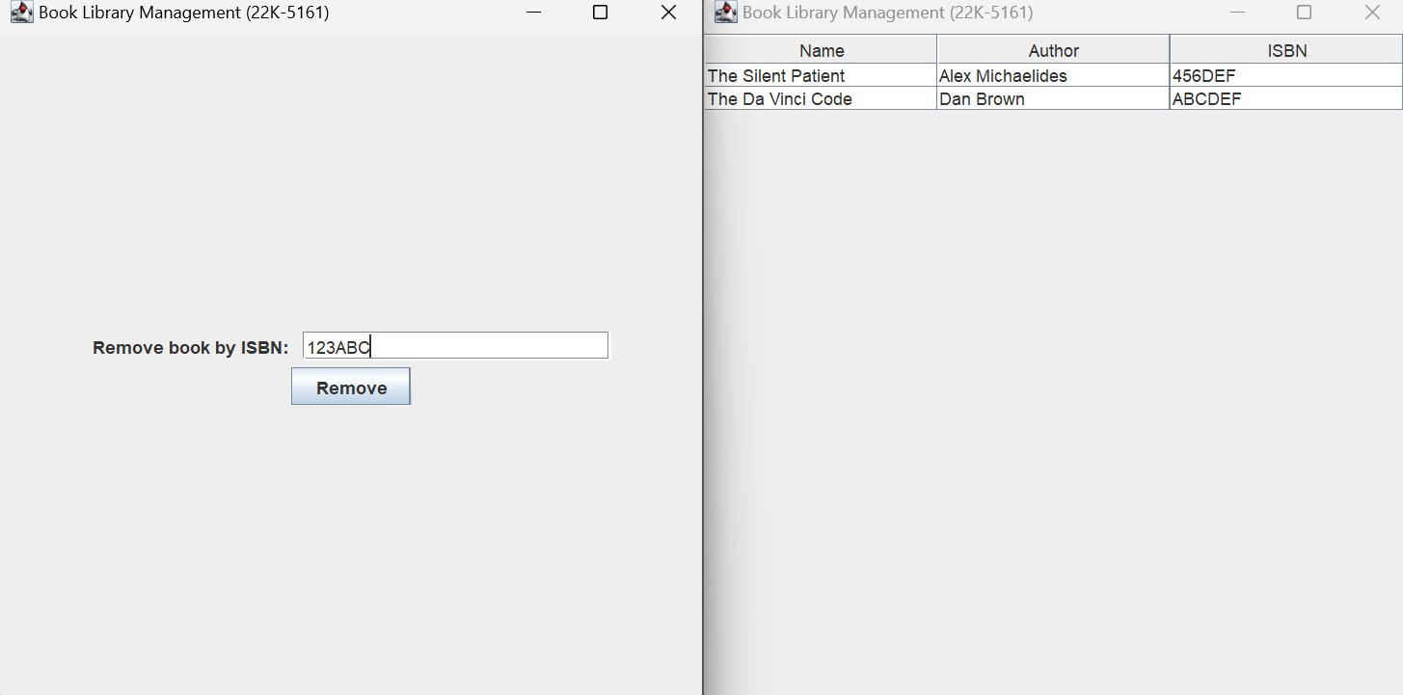

**Task no. 02**

Code:

//Hafsa Salman  
//22K-5161  
//Task no. 02  
  
import javax.swing.*;  
import java.awt.event.ActionEvent;  
import java.awt.event.ActionListener;  
import java.util.HashMap;  
  
public class Task_02 extends JFrame  
{  
 private JPanel Task_02;  
 private JButton addProductButton;  
 private JLabel SCS;  
 private JButton viewProductsButton;  
 private JButton updateProductsButton;  
 private JButton removeProductButton;  
 private JButton totalPriceButton;  
  
 public Task_02()  
 {  
 HashMap<String, Integer> Cart = new HashMap<>();  
 Cart.put("Apples", 5);  
 Cart.put("Bananas", 10);  
 Cart.put("Detergent", 1);  
 Cart.put("Knife", 2);  
  
 HashMap<String, Double> PriceList = new HashMap<>();  
 PriceList.put("Apples", 10.0);  
 PriceList.put("Bananas", 7.0);  
 PriceList.put("Detergent", 10.0);  
 PriceList.put("Knife", 5.0);  
 PriceList.put("Diapers", 15.0);  
 PriceList.put("Milk", 10.0);  
 PriceList.put("Pouch", 5.0);  
  
 addProductButton.addActionListener(new ActionListener()  
 {  
 @Override  
 public void actionPerformed(ActionEvent e)  
 {  
 new AddCart(Cart);  
 }  
 });  
  
 viewProductsButton.addActionListener(new ActionListener()  
 {  
 @Override  
 public void actionPerformed(ActionEvent e)  
 {  
 new ViewCart(Cart);  
 }  
 });  
  
 updateProductsButton.addActionListener(new ActionListener()  
 {  
 @Override  
 public void actionPerformed(ActionEvent e)  
 {  
 new Update(Cart);  
 }  
 });  
  
 removeProductButton.addActionListener(new ActionListener()  
 {  
 @Override  
 public void actionPerformed(ActionEvent e)  
 {  
 new RemoveFromCart(Cart, PriceList);  
 }  
 });  
  
 totalPriceButton.addActionListener(new ActionListener()  
 {  
 @Override  
 public void actionPerformed(ActionEvent e)  
 {  
 new TotalPrice(Cart, PriceList);  
 }  
 });  
 }  
  
 public static void main(String[] args)  
 {  
 Task_02 T2 = new Task_02();  
  
 T2.setContentPane(T2.Task_02);  
 T2.setTitle("Shopping Cart System (22K-5161)");  
 T2.setSize(500, 500);  
 T2.setVisible(true);  
  
 T2.setDefaultCloseOperation(*EXIT_ON_CLOSE*);  
 }  
}

//Hafsa Salman  
//22K-5161  
//Task no. 02  
  
import javax.swing.*;  
import java.awt.event.ActionEvent;  
import java.awt.event.ActionListener;  
import java.util.HashMap;  
  
public class AddCart extends JFrame  
{  
 private JLabel Label;  
 private JTextField textField1;  
 private JTextField textField2;  
 private JButton addButton;  
 private JPanel Adddd;  
  
 public AddCart(HashMap<String, Integer> Cart)  
 {  
 setContentPane(Adddd);  
 setTitle("Shopping Cart System (22K-5161)");  
 setSize(500,500);  
 setVisible(true);  
  
 addButton.addActionListener(new ActionListener()  
 {  
 @Override  
 public void actionPerformed(ActionEvent e)  
 {  
 String product = textField1.getText();  
 int quantity = Integer.*parseInt*(textField2.getText());  
  
 Cart.put(product, quantity);  
  
 new ViewCart(Cart);  
 }  
 });  
 }  
}

//Hafsa Salman  
//22K-5161  
//Task no. 02  
  
import javax.swing.*;  
import javax.swing.table.DefaultTableModel;  
import java.awt.*;  
import java.util.HashMap;  
  
public class ViewCart extends JFrame  
{  
 private JPanel View;  
  
 public ViewCart(HashMap<String, Integer> Cart)  
 {  
 setContentPane(View);  
 setTitle("Shopping Cart System (22K-5161)");  
 setSize(500,500);  
 setVisible(true);  
  
 View.setLayout(new BorderLayout());  
  
 String[] Columns = {"Product Names", "Quantity"};  
  
 Object[][] data = new Object[Cart.size()][Columns.length];  
  
 int i = 0;  
  
 for (HashMap.Entry<String, Integer> entry : Cart.entrySet())  
 {  
 data[i][0] = entry.getKey();  
 data[i][1] = entry.getValue();  
  
 i++;  
 }  
  
 DefaultTableModel model = new DefaultTableModel(data, Columns);  
  
 JTable table = new JTable(model);  
  
 JScrollPane scrollPane = new JScrollPane(table);  
  
 add(scrollPane, BorderLayout.*CENTER*);  
 }  
}

//Hafsa Salman  
//22K-5161  
//Task no. 02  
  
import javax.swing.*;  
import java.awt.event.ActionEvent;  
import java.awt.event.ActionListener;  
import java.util.HashMap;  
  
public class Update extends JFrame  
{  
 private JLabel Label;  
 private JTextField textField1;  
 private JButton updateButton;  
 private JLabel Ugh;  
 private JLabel quantityLabel;  
 private JTextField textField2;  
 private JPanel UPDATEEE;  
  
 public Update(HashMap<String, Integer> Cart)  
 {  
 setContentPane(UPDATEEE);  
 setTitle("Shopping Cart System (22K-5161)");  
 setSize(500,500);  
 setVisible(true);  
  
 updateButton.addActionListener(new ActionListener()  
 {  
 @Override  
 public void actionPerformed(ActionEvent e)  
 {  
 String productName = textField1.getText();  
 int quantity = Integer.*parseInt*(textField2.getText());  
  
 if (Cart.containsKey(productName))  
 {  
 Cart.put(productName, quantity);  
  
 new ViewCart(Cart);  
 }  
  
 else  
 {  
 JOptionPane.*showMessageDialog*(updateButton, "Product not found in cart.");  
 }  
 }  
 });  
 }  
}

//Hafsa Salman  
//22K-5161  
//Task no.02  
  
import javax.swing.*;  
import java.awt.event.ActionEvent;  
import java.awt.event.ActionListener;  
import java.util.HashMap;  
  
public class RemoveFromCart extends JFrame  
{  
 private JPanel Remove;  
 private JLabel Removeee;  
 private JTextField textField1;  
 private JButton removeButton;  
  
  
 public RemoveFromCart(HashMap<String, Integer> Cart, HashMap<String, Double> PriceList)  
 {  
 setContentPane(Remove);  
 setTitle("Shopping Cart System (22K-5161)");  
 setSize(500,500);  
 setVisible(true);  
  
 removeButton.addActionListener(new ActionListener()  
 {  
 @Override  
 public void actionPerformed(ActionEvent e)  
 {  
 String str = textField1.getText();  
  
 if (Cart.containsKey(str))  
 {  
 Cart.remove(str);  
 JOptionPane.*showMessageDialog*(removeButton, str + " has been removed from the cart.");  
 dispose();  
  
 new TotalPrice(Cart, PriceList);  
 }  
  
 else  
 {  
 JOptionPane.*showMessageDialog*(removeButton, str + " is not in the cart.");  
 }  
 }  
 });  
 }  
}

//Hafsa Salman  
//22K-5161  
//Task no. 02  
  
import javax.swing.*;  
import javax.swing.table.DefaultTableModel;  
import java.awt.*;  
import java.util.HashMap;  
  
public class TotalPrice extends JFrame  
{  
 private JPanel TotalPriceForm;  
 private JTextField textField1;  
 private JLabel TP;  
  
 public TotalPrice (HashMap<String, Integer> Cart, HashMap<String, Double> PriceList)  
 {  
 setContentPane(TotalPriceForm);  
 setTitle("Shopping Cart System (22K-5161)");  
 setSize(500,500);  
 setVisible(true);  
  
 TotalPriceForm.setLayout(new BorderLayout());  
  
 String[] Columns = {"Product Names", "Price (For one)", "Quantity", "Price (All)"};  
  
 Object[][] data = new Object[Cart.size()][Columns.length];  
  
 int i = 0;  
 double total = 0;  
  
 for (HashMap.Entry<String, Integer> entry : Cart.entrySet())  
 {  
 String productName = entry.getKey();  
 int quantity = entry.getValue();  
  
 Double price = PriceList.get(productName);  
 Double totalPrice = price * quantity;  
 total += totalPrice;  
  
 data[i][0] = productName;  
 data[i][1] = price;  
 data[i][2] = quantity;  
 data[i][3] = totalPrice;  
  
 i++;  
 }  
  
 DefaultTableModel model = new DefaultTableModel(data, Columns);  
  
 JTable table = new JTable(model);  
  
 JScrollPane scrollPane = new JScrollPane(table);  
  
 add(scrollPane, BorderLayout.*CENTER*);  
  
 textField1.setText(String.*valueOf*(total));  
 }  
}

Output:

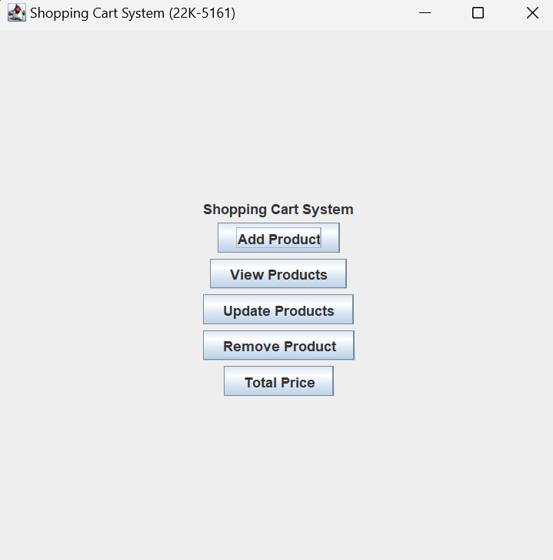

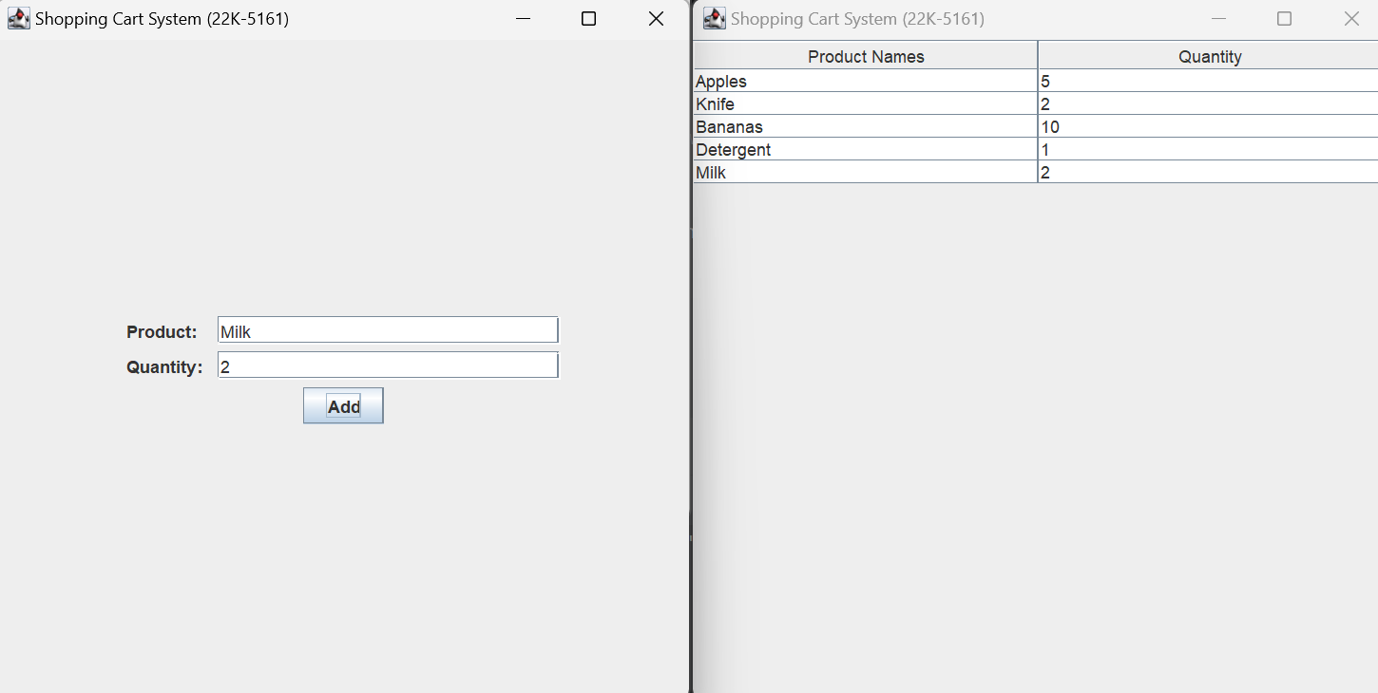

**Task no. 03**

Code:

//Hafsa Salman  
//22K-5161  
//Task no. 03  
  
import javax.swing.*;  
import java.awt.event.ActionEvent;  
import java.awt.event.ActionListener;  
import java.util.TreeMap;  
  
public class Task_03 extends JFrame  
{  
 private JLabel T3;  
 private JPanel Task_03;  
 private JButton addStudentButton;  
 private JButton displayStudentButton;  
 private JButton classStatisticsButton;  
  
 public Task_03()  
 {  
 TreeMap<String, Integer> Grades = new TreeMap<>();  
  
 Grades.put("Hafsa", 99);  
 Grades.put("Menahil", 87);  
 Grades.put("Bia", 2);  
 Grades.put("Ali", 67);  
  
 addStudentButton.addActionListener(new ActionListener()  
 {  
 @Override  
 public void actionPerformed(ActionEvent e)  
 {  
 new AddStudent(Grades);  
 }  
 });  
  
 displayStudentButton.addActionListener(new ActionListener()  
 {  
 @Override  
 public void actionPerformed(ActionEvent e)  
 {  
 new DisplayGrades(Grades);  
 }  
 });  
  
 classStatisticsButton.addActionListener(new ActionListener()  
 {  
 @Override  
 public void actionPerformed(ActionEvent e)  
 {  
 new Statistics(Grades);  
 }  
 });  
 }  
  
 public static void main(String[] args)  
 {  
 Task_03 T3 = new Task_03();  
  
 T3.setContentPane(T3.Task_03);  
 T3.setTitle("Student Grading System (22K-5161)");  
 T3.setSize(500, 500);  
 T3.setVisible(true);  
  
 T3.setDefaultCloseOperation(JFrame.*EXIT_ON_CLOSE*);  
 }  
}

//Hafsa Salman  
//22K-5161  
//Task no. 03  
  
import javax.swing.*;  
import java.awt.event.ActionEvent;  
import java.awt.event.ActionListener;  
import java.util.TreeMap;  
  
public class AddStudent extends JFrame  
{  
 private JLabel Label;  
 private JLabel Ugh;  
 private JTextField textField1;  
 private JTextField textField2;  
 private JButton addButton;  
 private JLabel gradeLabel;  
 private JPanel AddGrade;  
  
 public AddStudent(TreeMap<String, Integer> Grades)  
 {  
 setContentPane(AddGrade);  
 setTitle("Student Grading System (22K-5161)");  
 setSize(500, 500);  
 setVisible(true);  
  
 addButton.addActionListener(new ActionListener()  
 {  
 @Override  
 public void actionPerformed(ActionEvent e)  
 {  
 String name = textField1.getText();  
 int grade = Integer.*parseInt*(textField2.getText());  
  
 Grades.put(name, grade);  
  
 new DisplayGrades(Grades);  
 }  
 });  
 }  
}

//Hafsa Salman  
//22K-5161  
//Task no. 03  
  
import javax.swing.*;  
import javax.swing.table.DefaultTableModel;  
import java.awt.*;  
import java.util.Map;  
import java.util.TreeMap;  
  
public class DisplayGrades extends JFrame  
{  
 private JPanel Display;  
  
 public DisplayGrades(TreeMap<String, Integer> Grades)  
 {  
 setContentPane(Display);  
 setTitle("Student Grading System (22K-5161)");  
 setSize(500, 500);  
 setVisible(true);  
  
 setLayout(new BorderLayout());  
  
 String[] columnNames = {"Student Name", "Grade"};  
  
 Object[][] data = new Object[Grades.size()][2];  
  
 int i = 0;  
  
 for (Map.Entry<String, Integer> entry : Grades.entrySet())  
 {  
 data[i][0] = entry.getKey();  
 data[i][1] = entry.getValue();  
 i++;  
 }  
  
 DefaultTableModel model = new DefaultTableModel(data, columnNames);  
  
 JTable table = new JTable(model);  
  
 JScrollPane scrollPane = new JScrollPane(table);  
  
 add(scrollPane, BorderLayout.*CENTER*);  
 }  
}

//Hafsa Salman  
//22K-5161  
//Task no. 03  
  
import javax.swing.*;  
import java.util.Map;  
import java.util.TreeMap;  
  
public class Statistics extends JFrame  
{  
 private JPanel Stats;  
 private JLabel Average;  
 private JLabel Highest;  
 private JLabel Lowest;  
  
 public Statistics (TreeMap<String, Integer> Grades)  
 {  
 setContentPane(Stats);  
 setTitle("Student Grading System (22K-5161)");  
 setSize(500, 500);  
 setVisible(true);  
  
 int sum = 0;  
 int high = Integer.*MIN_VALUE*;  
 int low = Integer.*MAX_VALUE*;  
  
 for (Map.Entry<String, Integer> entry : Grades.entrySet())  
 {  
 int grade = entry.getValue();  
 sum += grade;  
  
 if (grade > high)  
 {  
 high = grade;  
 }  
  
 if (grade < low)  
 {  
 low = grade;  
 }  
 }  
  
 double average = sum / (double) Grades.size();  
  
 Average.setText("Class Average: " + String.*format*("%.2f", average));  
 Highest.setText("Highest Grade: " + high);  
 Lowest.setText("Lowest Grade: " + low);  
 }  
}

Output:

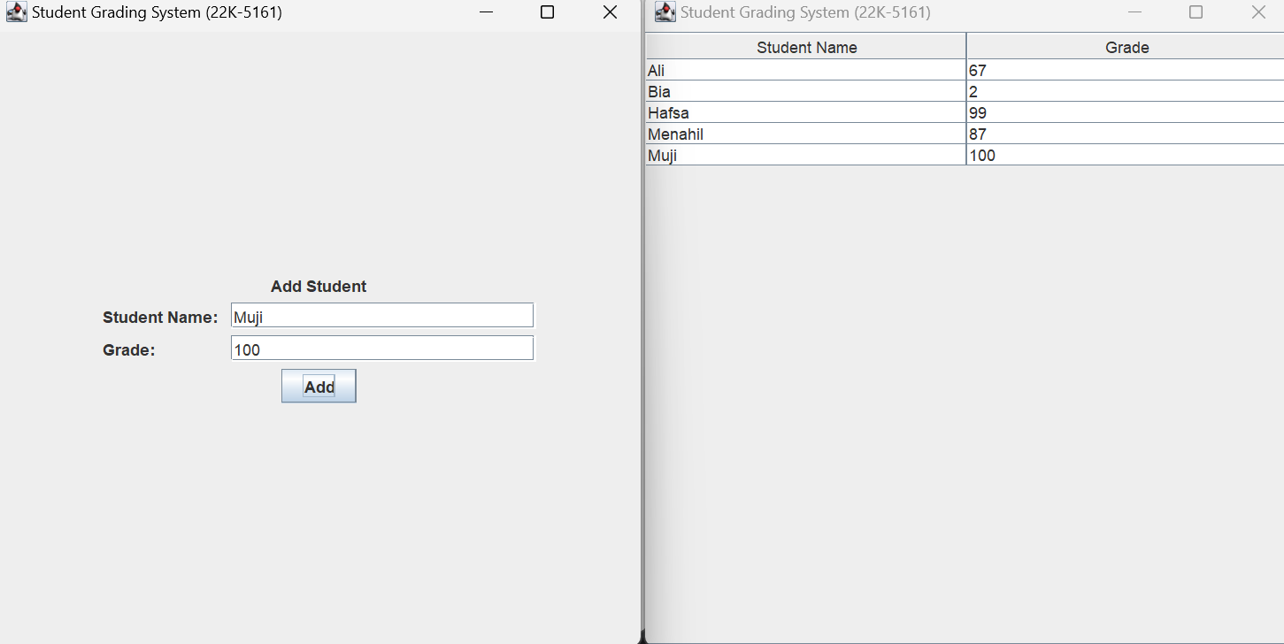

**Task no. 04**

Code:

//Hafsa Salman  
//22K-5161  
//Task no. 04  
  
import javax.swing.*;  
import java.awt.event.ActionEvent;  
import java.awt.event.ActionListener;  
import java.util.HashSet;  
  
public class Task_04 extends JFrame  
{  
 private JPanel Task_04;  
 private JLabel Label;  
 private JButton addContactButton;  
 private JButton displayContactButton;  
 private JButton searchByNameButton;  
 private JButton searchByPhoneNumberButton;  
  
 public Task_04()  
 {  
 HashSet<Contacts> ContactsList = new HashSet<>();  
  
 Contacts contact01 = new Contacts("Hafsa", "03001234567", "hafsa@gmail.com");  
 ContactsList.add(contact01);  
  
 Contacts contact02 = new Contacts("Alizah", "03007654321", "alizah@gmail.com");  
 ContactsList.add(contact02);  
  
 Contacts contact03 = new Contacts("Amna", "03111111111", "amna@gmail.com");  
 ContactsList.add(contact03);  
  
 addContactButton.addActionListener(new ActionListener()  
 {  
 @Override  
 public void actionPerformed(ActionEvent e)  
 {  
 new AddContact(ContactsList);  
 }  
 });  
  
 displayContactButton.addActionListener(new ActionListener()  
 {  
 @Override  
 public void actionPerformed(ActionEvent e)  
 {  
 new DisplayContact(ContactsList);  
 }  
 });  
  
 searchByNameButton.addActionListener(new ActionListener()  
 {  
 @Override  
 public void actionPerformed(ActionEvent e)  
 {  
 new SearchContactByName(ContactsList);  
 }  
 });  
  
 searchByPhoneNumberButton.addActionListener(new ActionListener()  
 {  
 @Override  
 public void actionPerformed(ActionEvent e)  
 {  
 new SearchContactByPhone(ContactsList);  
 }  
 });  
 }  
  
 public static void main(String[] args)  
 {  
 Task_04 T4 = new Task_04();  
  
 T4.setContentPane(T4.Task_04);  
 T4.setTitle("Contact List Application (22K-5161)");  
 T4.setSize(500, 500);  
 T4.setVisible(true);  
  
 T4.setDefaultCloseOperation(JFrame.*EXIT_ON_CLOSE*);  
 }  
}  
  
class Contacts  
{  
 String name;  
 String phone;  
 String email;  
  
 public Contacts (String name, String phone, String email)  
 {  
 this.name = name;  
 this.phone = phone;  
 this.email = email;  
 }  
  
 public String getName()  
 {  
 return name;  
 }  
  
 public String getPhoneNumber()  
 {  
 return phone;  
 }  
  
 public String getEmail()  
 {  
 return email;  
 }  
}

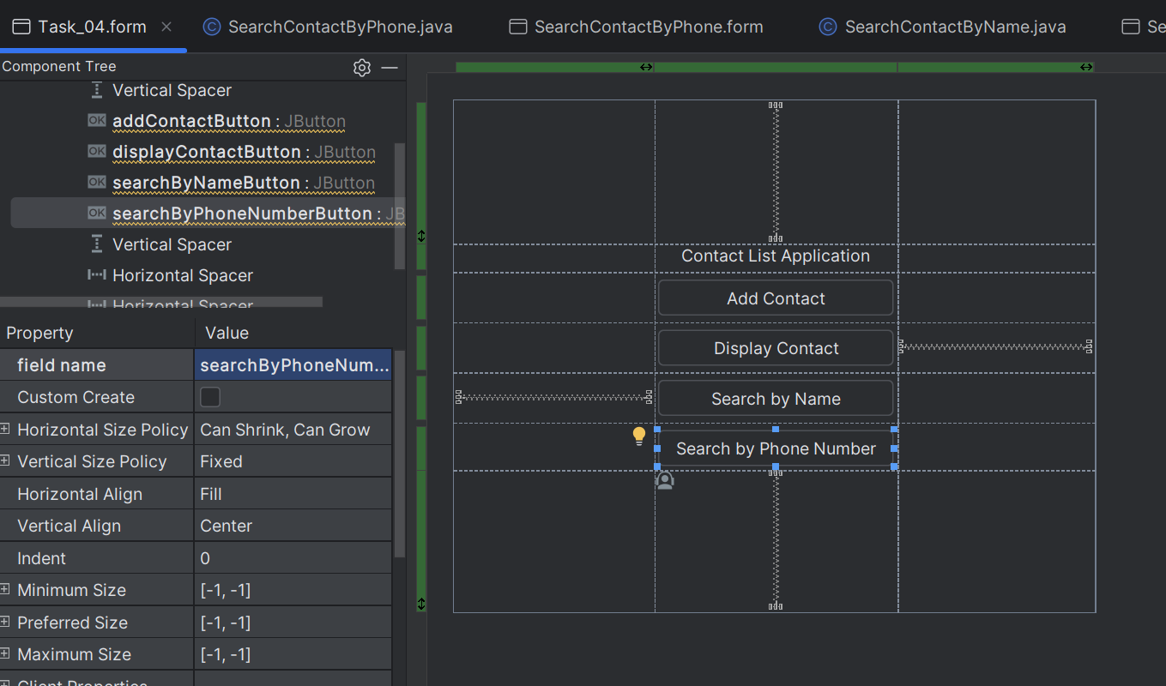

// Hafsa Salman  
// 22K-5161  
// Task no. 04  
  
import javax.swing.*;  
import java.awt.event.ActionEvent;  
import java.awt.event.ActionListener;  
import java.util.HashSet;  
  
public class AddContact extends JFrame  
{  
 private JPanel AddContact;  
 private JLabel AC;  
 private JLabel Whe;  
 private JTextField textField1;  
 private JTextField textField2;  
 private JTextField textField3;  
 private JLabel Email;  
 private JLabel Phone;  
 private JButton addButton;  
  
 public AddContact(HashSet<Contacts> ContactsList)  
 {  
 setContentPane(AddContact);  
 setTitle("Contact List Application (22K-5161)");  
 setSize(500, 500);  
 setVisible(true);  
  
 addButton.addActionListener(new ActionListener()  
 {  
 @Override  
 public void actionPerformed(ActionEvent e)  
 {  
 String Name = textField1.getText().trim();  
 String Phone = textField2.getText().trim();  
 String Email = textField3.getText().trim();  
  
 if (Name.isEmpty() || Phone.isEmpty() || Email.isEmpty())  
 {  
 JOptionPane.*showMessageDialog*(addButton, "All fields must be filled!");  
 }  
  
 if (isDuplicate(Name, Phone, ContactsList))  
 {  
 JOptionPane.*showMessageDialog*(addButton, "Contact with the same name or phone number already exists!");  
 }  
  
 else  
 {  
 Contacts newContact = new Contacts(Name, Phone, Email);  
 ContactsList.add(newContact);  
  
 JOptionPane.*showMessageDialog*(addButton, "New contact added successfully!");  
  
 new DisplayContact(ContactsList);  
 }  
 }  
 });  
 }  
  
 private boolean isDuplicate(String Name, String Phone, HashSet<Contacts> ContactsList)  
 {  
 for (Contacts contact : ContactsList)  
 {  
 if (contact.getName().equalsIgnoreCase(Name) || contact.getPhoneNumber().equals(Phone))  
 {  
 return true;  
 }  
 }  
  
 return false; // No duplicate  
 }  
}

//Hafsa Salman  
//22K-5161  
//Task no. 04  
  
import javax.swing.*;  
import javax.swing.table.DefaultTableModel;  
import java.awt.*;  
import java.util.HashSet;  
  
public class DisplayContact extends JFrame  
{  
 public DisplayContact(HashSet<Contacts> ContactsList)  
 {  
  
 setTitle("Contact List Application (22K-5161)");  
 setSize(500, 500);  
 setVisible(true);  
  
 setLayout(new BorderLayout());  
  
 String[] columnNames = {"Name", "Phone Number", "Email"};  
  
 Object[][] data = new Object[ContactsList.size()][3];  
  
 int i = 0;  
  
 for (Contacts contact : ContactsList)  
 {  
 data[i][0] = contact.getName();  
 data[i][1] = contact.getPhoneNumber();  
 data[i][2] = contact.getEmail();  
  
 i++;  
 }  
  
 DefaultTableModel model = new DefaultTableModel(data, columnNames);  
  
 JTable table = new JTable(model);  
  
 JScrollPane scrollPane = new JScrollPane(table);  
  
 add(scrollPane, BorderLayout.*CENTER*);  
 }  
}

//Hafsa Salman  
//22K-5161  
//Task no. 04  
  
import javax.swing.*;  
import java.awt.event.ActionEvent;  
import java.awt.event.ActionListener;  
import java.util.HashSet;  
  
public class SearchContactByName extends JFrame  
{  
 private JLabel Whe;  
 private JPanel SearchName;  
 private JLabel Name;  
 private JTextField textField1;  
 private JButton searchButton;  
  
 public SearchContactByName (HashSet<Contacts> ContactsList)  
 {  
 setContentPane(SearchName);  
 setTitle("Contact List Application (22K-5161)");  
 setSize(500, 500);  
 setVisible(true);  
  
 searchButton.addActionListener(new ActionListener()  
 {  
 @Override  
 public void actionPerformed(ActionEvent e)  
 {  
 String name = textField1.getText().trim();  
  
 if (name.isEmpty())  
 {  
 JOptionPane.*showMessageDialog*(searchButton, "Please enter a name to search!");  
  
 return;  
 }  
  
 Contacts result = searchContactByName(name, ContactsList);  
  
 if (result != null)  
 {  
 JOptionPane.*showMessageDialog*(searchButton, "Contact Found!\nName: " + result.getName() + "\nPhone: " + result.getPhoneNumber() + "\nEmail: " + result.getEmail(), "Contact Found", JOptionPane.*INFORMATION_MESSAGE*);  
 }  
  
 else  
 {  
 JOptionPane.*showMessageDialog*(searchButton, "Contact not found!", "Error", JOptionPane.*ERROR_MESSAGE*);  
 }  
 }  
 });  
 }  
  
 private Contacts searchContactByName(String name, HashSet<Contacts> ContactsList)  
 {  
 for (Contacts contact : ContactsList)  
 {  
 if (contact.getName().equalsIgnoreCase(name))  
 {  
 return contact;  
 }  
 }  
 return null;  
 }  
}

//Hafsa Salman  
//22K-5161  
//Task no. 04  
  
import javax.swing.*;  
import java.awt.event.ActionEvent;  
import java.awt.event.ActionListener;  
import java.util.HashSet;  
  
public class SearchContactByPhone extends JFrame  
{  
 private JLabel Label;  
 private JLabel Phone;  
 private JTextField textField1;  
 private JButton searchButton;  
 private JPanel SearchContact;  
  
 public SearchContactByPhone(HashSet<Contacts> ContactsList)  
 {  
 setContentPane(SearchContact);  
 setTitle("Contact List Application (22K-5161)");  
 setSize(500, 500);  
 setVisible(true);  
  
 searchButton.addActionListener(new ActionListener()  
 {  
 @Override  
 public void actionPerformed(ActionEvent e)  
 {  
 String phone = textField1.getText();  
  
 if (phone.isEmpty())  
 {  
 JOptionPane.*showMessageDialog*(searchButton, "Please enter a name to search!");  
  
 return;  
 }  
  
 Contacts result = searchContactByPhone(phone, ContactsList);  
  
 if (result != null)  
 {  
 JOptionPane.*showMessageDialog*(searchButton, "Contact Found!\nName: " + result.getName() + "\nPhone: " + result.getPhoneNumber() + "\nEmail: " + result.getEmail(), "Contact Found", JOptionPane.*INFORMATION_MESSAGE*);  
 }  
  
 else  
 {  
 JOptionPane.*showMessageDialog*(searchButton, "Contact not found!", "Error", JOptionPane.*ERROR_MESSAGE*);  
 }  
 }  
 });  
 }  
  
 private Contacts searchContactByPhone(String phone, HashSet<Contacts> ContactsList)  
 {  
 for (Contacts contact : ContactsList)  
 {  
 if (contact.getPhoneNumber().equals(phone))  
 {  
 return contact;  
 }  
 }  
 return null;  
 }  
}

Output:

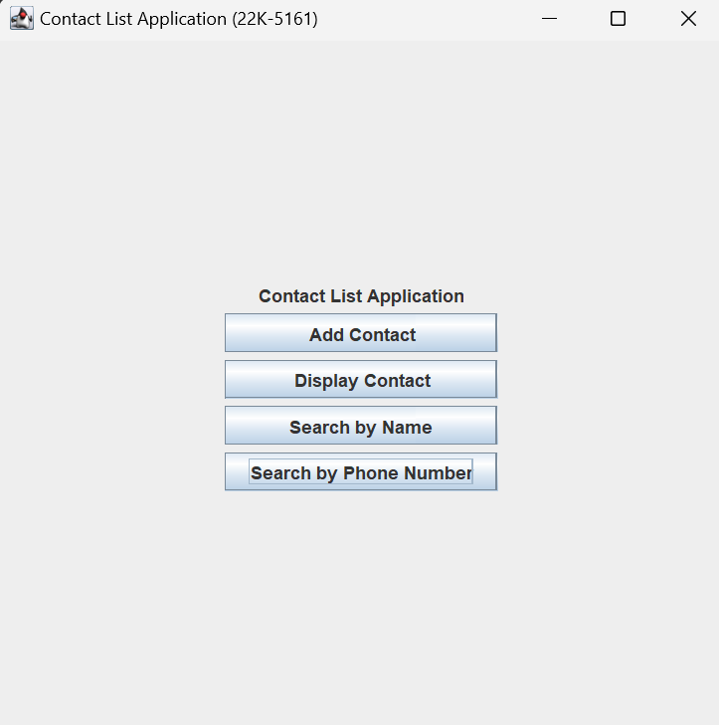

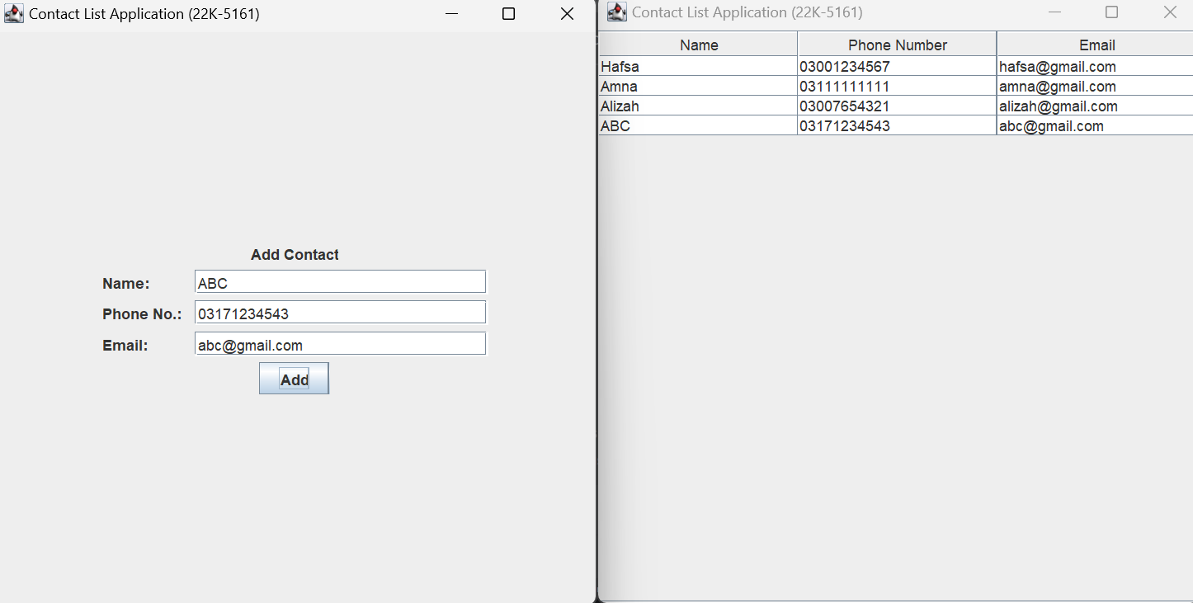

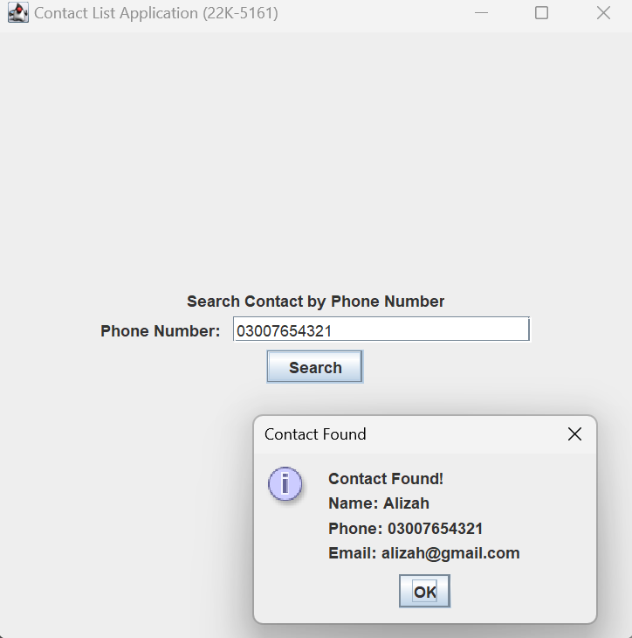

**Task no. 05**

Code:

//Hafsa Salman  
//22K-5161  
//Task no. 05  
  
import javax.swing.*;  
import java.awt.event.ActionEvent;  
import java.awt.event.ActionListener;  
import java.util.ArrayList;  
  
public class Task_05 extends JFrame  
{  
 private JPanel Task_05;  
 private JLabel Label;  
 private JButton addTaskButton;  
 private JButton displayTasksButton;  
 private JButton markAsCompletedButton;  
 private JButton clearButton;  
  
 public Task_05()  
 {  
 ArrayList <String> List = new ArrayList<>();  
  
 List.add("SCD Lab 05");  
 List.add("SCD Lab 06");  
 List.add("DB Lab 06");  
 List.add("DB Lab 07");  
 List.add("SQE Assignment 01");  
  
 addTaskButton.addActionListener(new ActionListener()  
 {  
 @Override  
 public void actionPerformed(ActionEvent e)  
 {  
 new AddTasks(List);  
 }  
 });  
  
 displayTasksButton.addActionListener(new ActionListener()  
 {  
 @Override  
 public void actionPerformed(ActionEvent e)  
 {  
 new DisplayTasks(List);  
 }  
 });  
  
 markAsCompletedButton.addActionListener(new ActionListener()  
 {  
 @Override  
 public void actionPerformed(ActionEvent e)  
 {  
 new CompletedTasks(List);  
 }  
 });  
  
 clearButton.addActionListener(new ActionListener()  
 {  
 @Override  
 public void actionPerformed(ActionEvent e)  
 {  
 JOptionPane.*showMessageDialog*(clearButton, "Tasks Cleared!");  
 }  
 });  
 }  
  
 public static void main(String[] args)  
 {  
 Task_05 T5 = new Task_05();  
  
 T5.setContentPane(T5.Task_05);  
 T5.setTitle("To-Do List Application (22K-5161)");  
 T5.setSize(500, 500);  
 T5.setVisible(true);  
  
 T5.setDefaultCloseOperation(JFrame.*EXIT_ON_CLOSE*);  
 }  
}

//Hafsa Salman  
//22K-5161  
//Task no. 05  
  
import javax.swing.*;  
import java.awt.event.ActionEvent;  
import java.awt.event.ActionListener;  
import java.util.ArrayList;  
  
public class CompletedTasks extends JFrame  
{  
 private JLabel Label;  
 private JPanel CompletedTasks;  
 private JLabel Task;  
 private JTextField textField1;  
 private JButton markAsCompletedButton;  
  
 public CompletedTasks(ArrayList<String> List)  
 {  
 setContentPane(CompletedTasks);  
 setTitle("To-Do List Application (22K-5161)");  
 setSize(500, 500);  
 setVisible(true);  
  
 markAsCompletedButton.addActionListener(new ActionListener()  
 {  
 @Override  
 public void actionPerformed(ActionEvent e)  
 {  
 String task = textField1.getText();  
  
 for (String t : List)  
 {  
 if (task.equals(t))  
 {  
 List.remove(t);  
  
 break;  
 }  
 }  
  
 new DisplayTasks(List);  
 }  
 });  
 }  
}

//Hafsa Salman  
//22K-5161  
//Task no. 05  
  
import javax.swing.*;  
import java.awt.event.ActionEvent;  
import java.awt.event.ActionListener;  
import java.util.ArrayList;  
  
public class AddTasks extends JFrame  
{  
 private JLabel Label;  
 private JLabel Task;  
 private JTextField textField1;  
 private JButton addButton;  
 private JPanel AddTasks;  
  
 public AddTasks(ArrayList<String> List)  
 {  
 setContentPane(AddTasks);  
 setTitle("To-Do List Application (22K-5161)");  
 setSize(500, 500);  
 setVisible(true);  
  
 addButton.addActionListener(new ActionListener()  
 {  
 @Override  
 public void actionPerformed(ActionEvent e)  
 {  
 String task = textField1.getText();  
  
 List.add(task);  
  
 new DisplayTasks(List);  
 }  
 });  
 }  
}

// Hafsa Salman  
// 22K-5161  
// Task no. 05  
  
import javax.swing.*;  
import javax.swing.table.DefaultTableModel;  
import java.awt.*;  
import java.util.ArrayList;  
  
public class DisplayTasks extends JFrame  
{  
 private JPanel Displaaaaaay;  
  
 public DisplayTasks(ArrayList<String> List)  
 {  
 setContentPane(Displaaaaaay);  
 setTitle("To-Do List Application (22K-5161)");  
 setSize(500, 500);  
 setVisible(true);  
  
 setLayout(new BorderLayout());  
  
 String[] columnNames = {"Tasks"};  
  
 DefaultTableModel tableModel = new DefaultTableModel(columnNames, 0);  
  
 for (String task : List)  
 {  
 tableModel.addRow(new Object[]{task});  
 }  
  
 JTable taskTable = new JTable(tableModel);  
  
 JScrollPane scrollPane = new JScrollPane(taskTable);  
  
 add(scrollPane, BorderLayout.*CENTER*);  
 }  
}

Output:



